**Collecting Rainwater?**

**Got a Well?**

**Conserving Water? Show us how!**

If you have a water collection system on your property with a capacity of 1800 litres or 400 imperial gallons tell us about it and get a sign like this to proudly display in your yard.

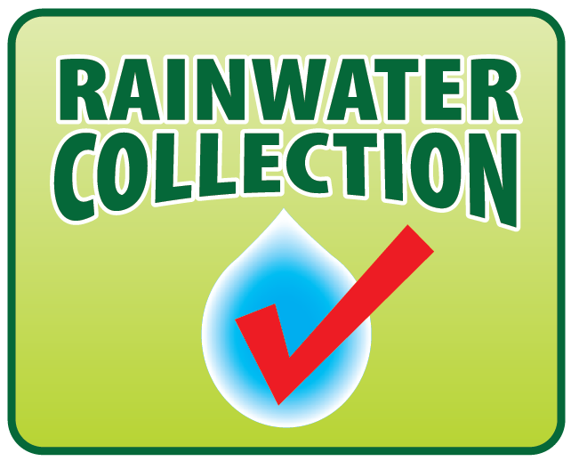

To qualify contact us at trincomali7925@gmail.com to arrange for validation and receive your sign.